Segmentation **in radiotherapy  
OAR segmentation:**Our organ segmentation method significantly enhances accuracy across pediatric and adult datasets, excelling in delineating both small, complex structures and larger organs, with notable DICE score improvements in challenging areas like the uterocervix, prostate, and gallbladder. However, performance disparities between pediatric and adult groups reveal fairness challenges in cross-dataset predictions, highlighting the need to address population-specific characteristics in model development. These findings underscore the importance of ensuring fairness, robustness, and generalizability in AI-driven anatomical segmentation for diverse demographics, with further research needed to optimize clinical applicability.

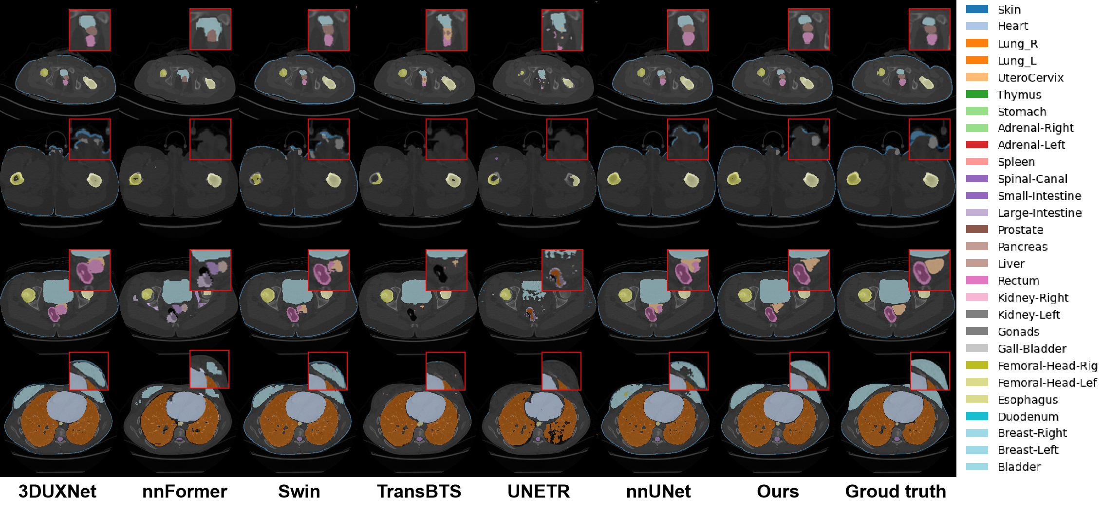

**NPC segmentation:**Our study introduces a novel multi-modal, multi-task deep learning framework designed for simultaneous segmentation of organs at risk (OARs), gross tumor volume (GTV), and clinical target volume (CTV). By jointly learning anatomical structures and tumor targets, the model leverages anatomical prior knowledge embedded in CT data to enhance tumor segmentation accuracy. We further incorporate gradient surgery techniques to mitigate conflicts between segmentation tasks, optimizing gradient interactions to boost model robustness. Experimental results show that this approach delivers substantial performance improvements in multi-modal, multi-task medical image segmentation, highlighting its potential for clinical applications.

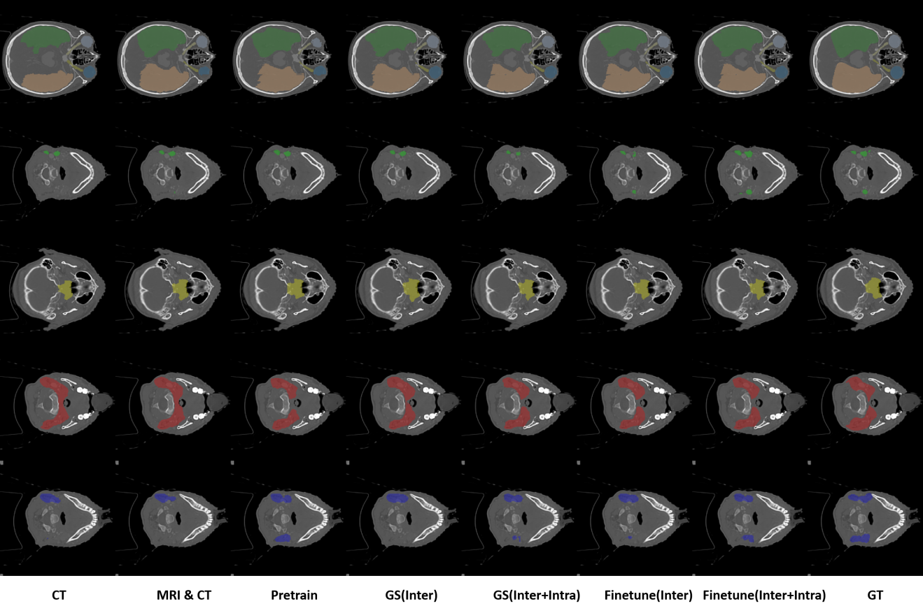

**Generation in radiotherapy**

**MR-CT Generation:** Our groundbreaking unified framework enables seamless MR-to-CT synthesis across all anatomical regions in a single comprehensive model. This innovative solution eliminates the need for multiple region-specific approaches, offering unprecedented versatility while maintaining exceptional image quality and anatomical accuracy throughout the entire body. The technology delivers consistent performance across diverse patient populations and scanning protocols, significantly enhancing clinical workflows in radiation therapy planning, PET-MR attenuation correction, and multimodal image registration while reducing acquisition costs and radiation exposure.

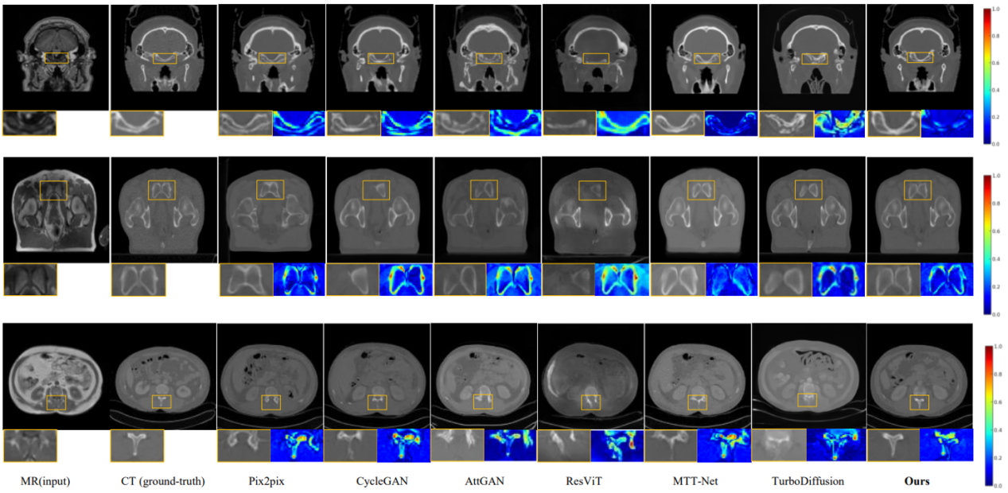

**CBCT-CT Generation:** Our innovative approach enables CBCT-to-CT conversion across all anatomical regions through a unified computational framework, delivering whole-body image transformation with remarkable consistency and precision without requiring multiple specialized models. This versatile solution transforms low-dose, artifact-prone CBCT acquisitions into diagnostic-quality CT images with exceptional fidelity across all anatomical regions, from cranial structures to pelvic anatomy. The technology enables adaptive radiotherapy planning, enhances dose calculation accuracy, and facilitates longitudinal patient monitoring while maintaining consistent performance across various CBCT systems and acquisition parameters, ultimately improving treatment outcomes while reducing patient imaging burdens.

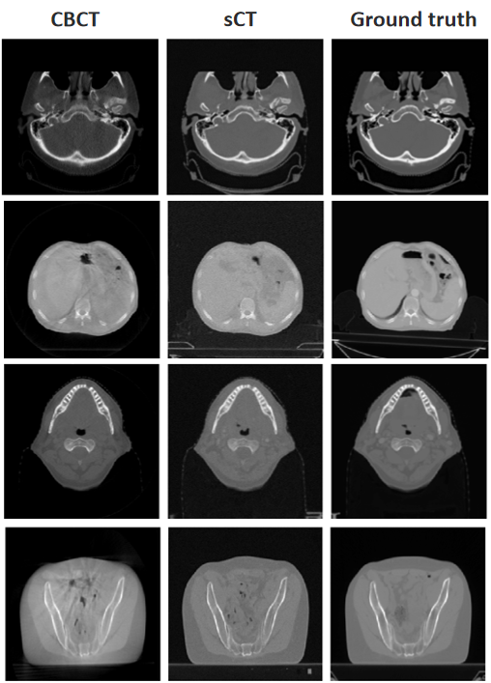

**Dose distribution prediction in radiotherapy**

1. We innovatively introduced the concept of dose channel into the traditional architecture of Generative Adversarial Networks (GAN), and thus constructed the Beam Channel Generative Adversarial Networks (abbreviated as Bc-GAN). Our network has successfully broken through the limitations of previous dose distribution prediction models that could only focus on a single radiotherapy technology (for instance, traditional GANs merely concentrated on one specific technology). It can now achieve precise predictions for mixed datasets of radiotherapy (covering multiple technologies such as Intensity Modulated Radiotherapy (IMRT) and Volumetric Modulated Arc Therapy (VMRT)). This innovative achievement lays a solid foundation for the future realization of automated radiotherapy planning and is expected to propel the field of radiotherapy towards more intelligent and precise development.



Fig. 1 Comparison examples of predicted and true dose; the plot was obtained by random sampling; the first line: CT images; the second line: the true dose map; the third line: the predicted dose map.

1. We have proposed a novel Swin-UMamba-Channel prediction model specifically designed for predicting the radiotherapy dose distribution in patients with left-sided breast cancer who have undergone total mastectomy. This model, by integrating anatomical positional information of organs with beam angle data, significantly enhances prediction accuracy. The successful development of this model assists physicists in rapidly generating dose-volume histogram (DVH) curves and shortens the treatment planning cycle. This work also provides valuable reference data for subsequent plan optimization and quality control, opening up new avenues for the application of deep learning in the field of radiotherapy. 

Fig. 2 Comparison of predicted dose and original dose in two cases. The left side (A, C) are the predicted dose image, and the right side (B, D)is the original dose image.